Jessica Christopher

Aging-model project

Midterm Output

> calculate.s.m = function( lifespan ){ #lifespan is simulated data

+ my.data = sort( lifespan[!is.na(lifespan)] );

+ deathFreq = table( my.data )

+ deathCumulative = deathFreq

+ for( i in 2:length(deathFreq)) {

+ deathCumulative[i] = deathCumulative[i-1] + deathCumulative[i]

+ }

+ tot = length(my.data)

+ s = 1 - deathCumulative/tot

+ currentLive = tot - deathCumulative

+ m = deathFreq / currentLive;

+

+ #list( s=s, t=unique(my.data));

+ ret = data.frame( cbind(s, m, unique(my.data)));

+ names(ret) = c("s", "m", "t");

+ ret;

+ }

>

>

> n = 50; # numOfComponents per block

> Npop = 1E3; # numOfSystems (individuals for simulation to calculate s and m)

>

> mymean = 0.1;

> mysds = c(0.1, 0.3, 0.5, 1, 1.3, 1.5);

>

>

> for ( mysd in mysds) {

+ #mu.vec = rlnorm(n, mean=2, sd=2) #linear m ~ t

+ mu.vec = rlnorm(n, mean=0.2, sd=1) #sigmoidal s, and m

+

+ #mu.vec = rlnorm(n, mean=0.2, sd=0.2) #linear m ~ t, smaller variance -> more linear

+ #mu.vec = rlnorm(n, mean=0.1, sd=2) #larger variance, linear log(m) ~ t!!!YES.

+ #mu.vec = rlnorm(n, mean=0.1, sd=2) #larger variance, linear log(m) ~ t!!!YES.

+ #mu.vec = rlnorm(n, mean=1, sd=25) #larger variance, linear log(m) ~ t!!!YES.

+ #mu.vec = rlnorm(n, mean=0.1, sd=5) #larger variance, linear log(m) ~ t!!!YES.

+

+ SystemAges = numeric(100);

+

+ for( i in 1: Npop){

+ componentAges = rexp(n, rate=mu.vec);

+ summary(componentAges);

+ SystemAges[i] = floor( max(componentAges) + 0.5 ); #extreme value distribution??

+ }

+

+

+ tb = calculate.s.m( SystemAges )

+ #sub = tb[1:floor(length(tb[,1])/4), ]

+ sub = tb[ tb$s > 0.25, ]

+ # Take on the initial phase, because reliability model

+ # works best during the initial phase.

+

+ #with( sub, plot( m ~ t))

+ #with( sub, plot( s~ t ))

+

+ sub$m[sub$m==0] = NA; #remove zero for log operations

+ plot (log(sub$m) ~ sub$t, main = paste("sd=", mysd) ) #plot the mortality ~ age

+ #m = with( sub, lm( log(m) ~ t) ); # linear regression

+ #m = lm( log(sub$m[sub$t<7]) ~ sub$t[sub$t<7] )

+ #abline(m, col="red")

+ #summary(lm( log(sub$m) ~ sub$t))

+

+ plot( sub$s ~ sub$t, main=paste("sd=", mysd) )

+ }

(Mortality Rate Plot: mortality rate vs. time)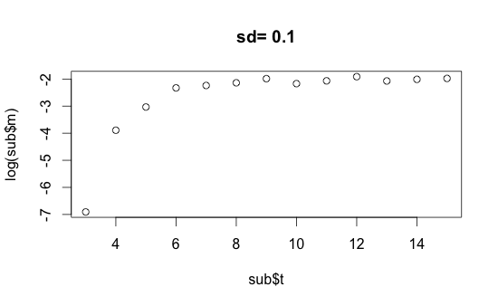

(Viability Plot: viability vs. time)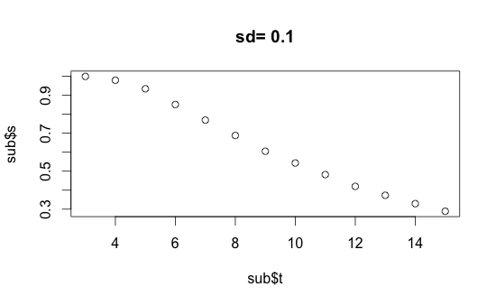

(Mortality Rate Plot: mortality rate vs. time)

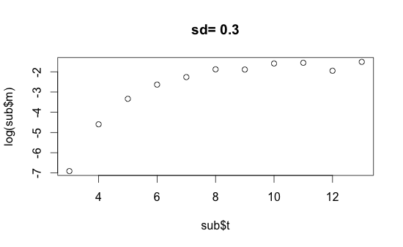

(Viability Plot: viability vs. time)

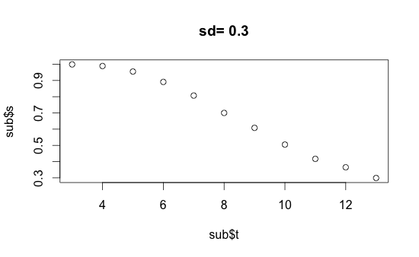

(Mortality Rate Plot: mortality rate vs. time)

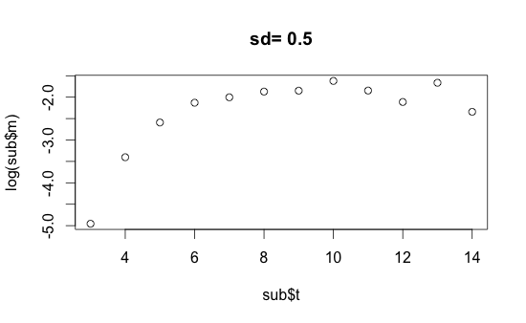

(Viability Plot: viability vs. time)

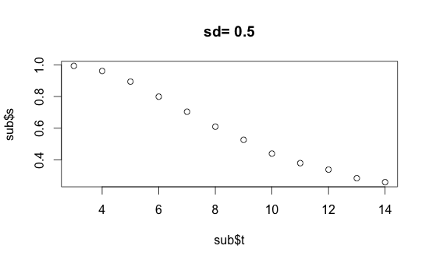

(Mortality Rate Plot: mortality rate vs. time)

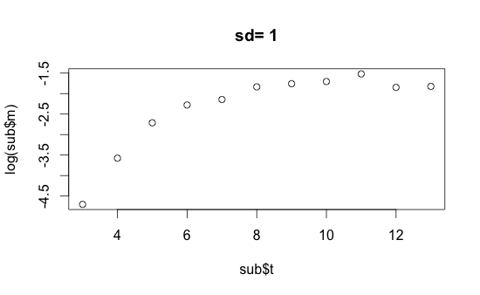

(Viability Plot: viability vs. time)

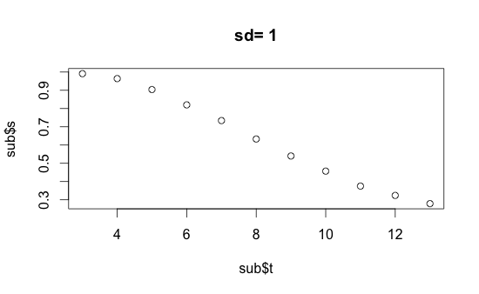

(Mortality Rate Plot: mortality rate vs. time)

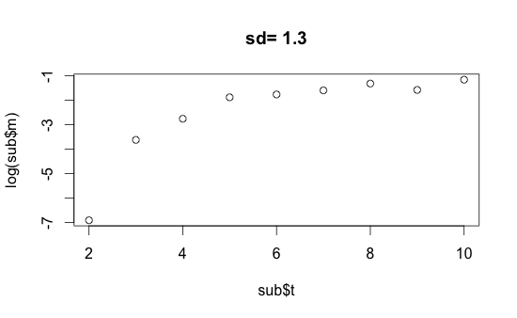

(Viability Plot: viability vs. time)

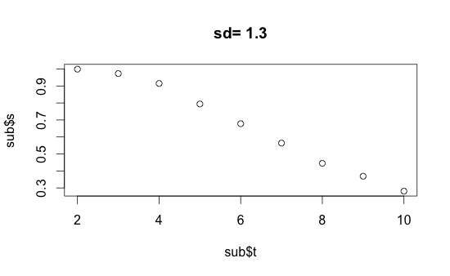

(Mortality Rate Plot: mortality rate vs. time)

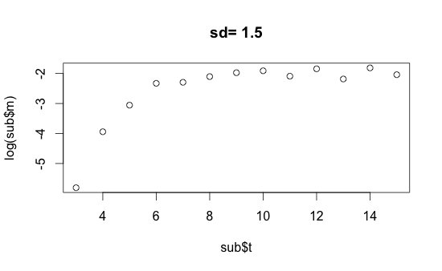

(Viability Plot: viability vs. time)

